# heartbeat

Heartbeat is an application that checks if instance of both Jenkins and Selenium-Grid are avaliable to use

### Configuration

Configuration of Jenkins, Selenium-Grid heartbeat service:

* unzip heartbeat.zip archive
* inside there are files:
  + - heartbeat.jar => application that checks wheather Jenkins or Selenium-Grid are working
  + - jenkins.config.json => configuration file with json list with separated entries for each Jenkins instance (url, username, pass)
  + - grid.config.json => configuration file with json list with separated entries for each Selenium-Grid instance (url)
  + - haertbeat.properties => application configuration file with path to the jenkins.config, grid.config, report.csv
  + - Heartbeat.xml => Windows task for TaskScheduler

* open jenkins.config.json. There are two sample entreis to get the feel how to add new instance of Jenkis:
  + url = it's the IP of machine where Jenkins works remeber to add proper port
  + username = username
  + password = password; this two are now not used so there is no need to enter any

* open grid.config.json. There is one sample entry. Modify this one and add new one like you did in previous file (jenkins.config.json)
  + url = it's the IP of machine where Selenium-Grid is registered remeber to add propert port

* if you want you can configure the placeholder for jenkins.config.json, grid.config.json, report.csv in heartbeat.properties. To that simply:
  + open heartbeat.properties and modify path with absolute context. REMBER DO NOT CHANGE LOCATION OF heartbeat.properties.

* open TaskScheduler:
  + go to StartMenu pass TaskScheduler in search box and click enter

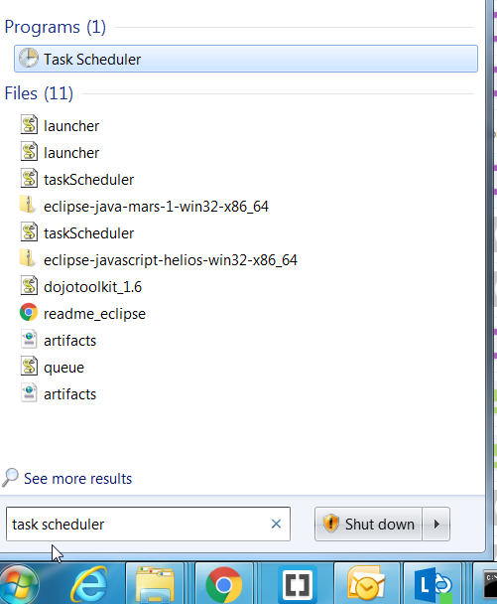

* + click on Actions -> Import Task

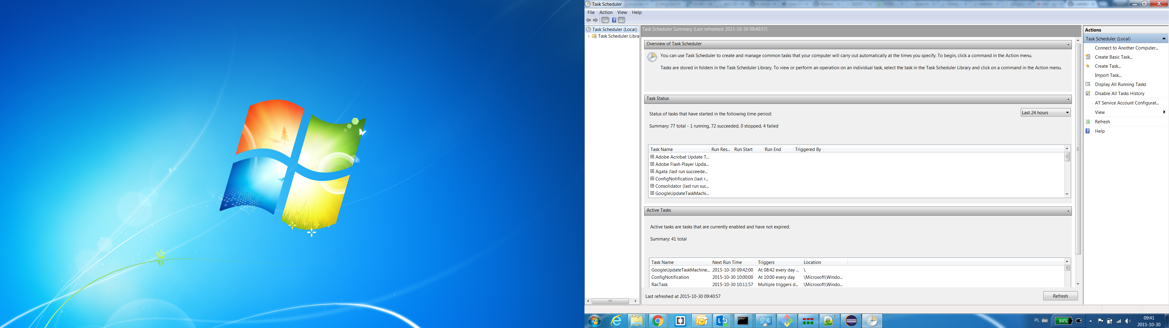

* + go to catalog where you've downloaded heartbeat archive and pick Heartbeat.xml file
  + navigate to Actions tab:
    - click edit

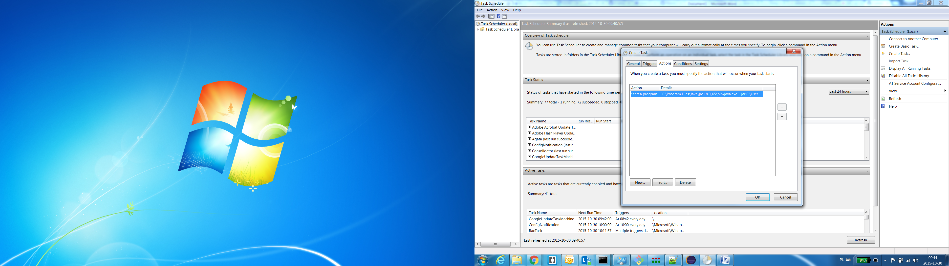

* + - pick "Start a program"
    - in "Program/script" box write your Java path "path/to/java/jre/bin/java.exe"
    - in "Add arguments" box write "- jar path/to/heartbeat/heartbeat.jar"
    - in "Start in" box write path to heartbeat "path/to/heartbeat/"
    - click ok

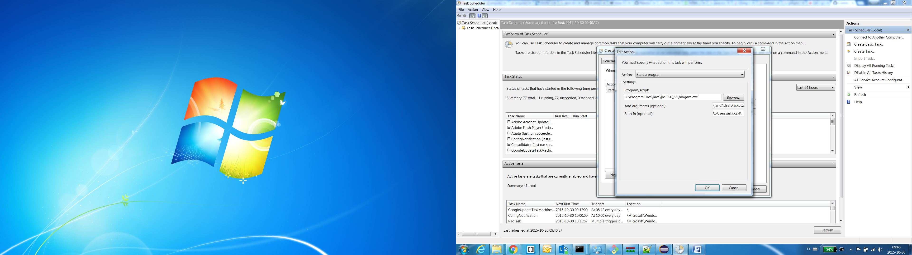

* + - click ok
  + navigate to Trigger tab if you want to configure how frequently the task is scheduled

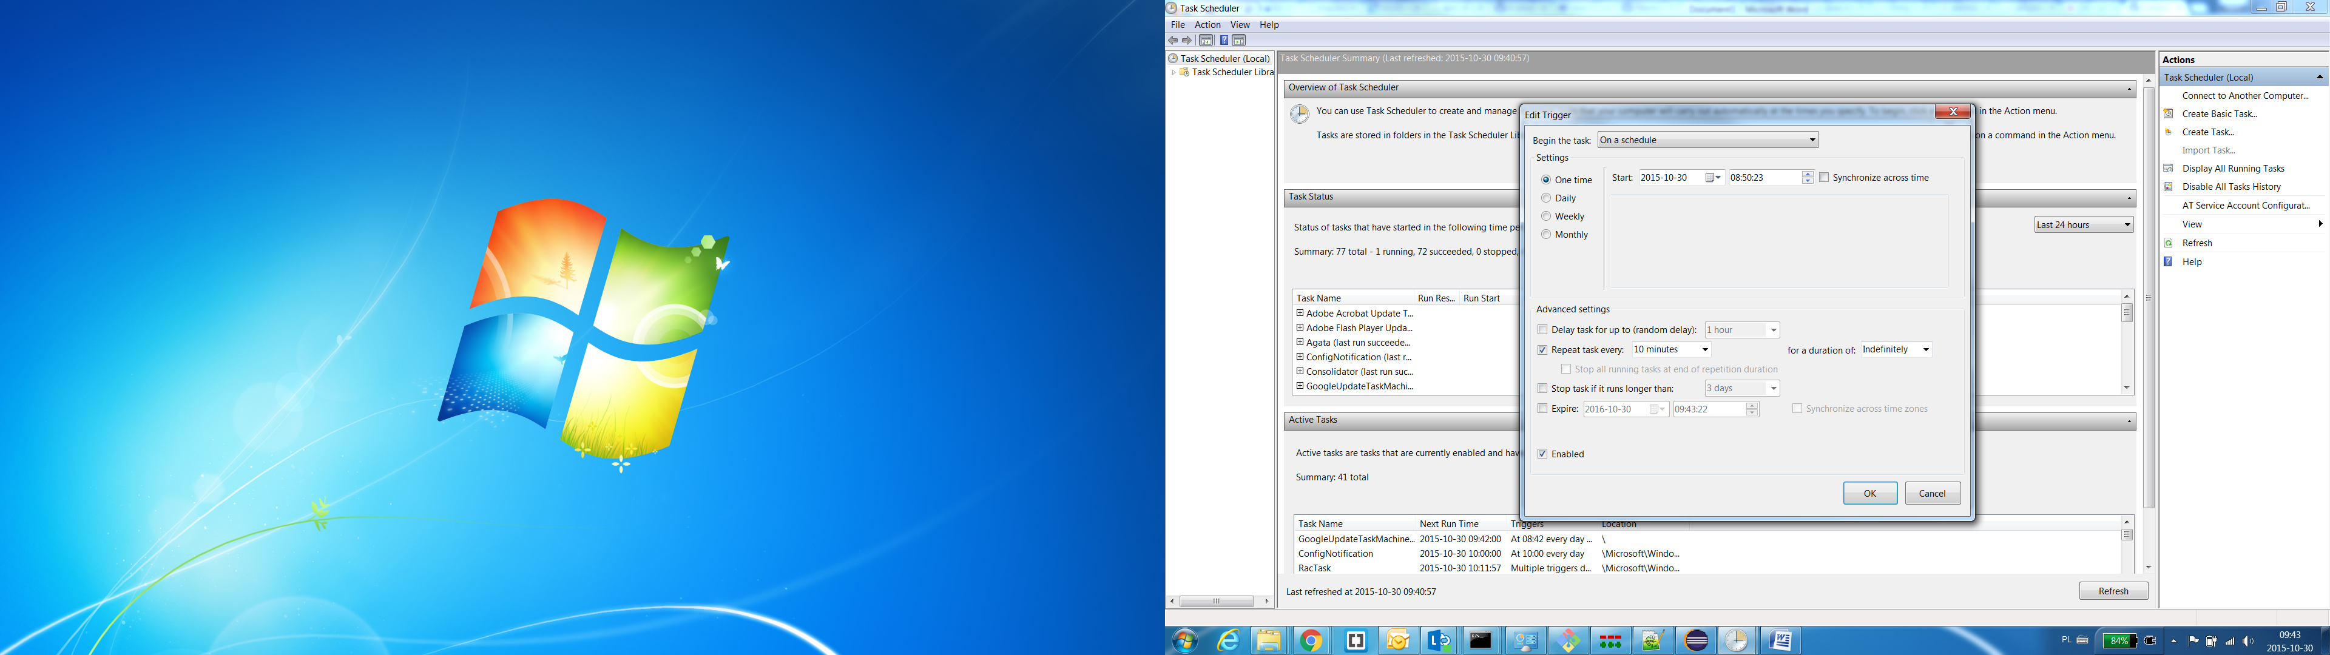

* + - click ok
  + on a dialog that pops up choose your user and pass your creadentials
  + click ok
  + go back to the the list of task
* on the lower list you should now see your new task "Heartbeat" (if not click "Refresh" on the right side)
* in the upper list you should see status of your new "Heartbeat" task (it will be updated after first run)

